**MOCKUP PROJECT BANK SAMPA**

* 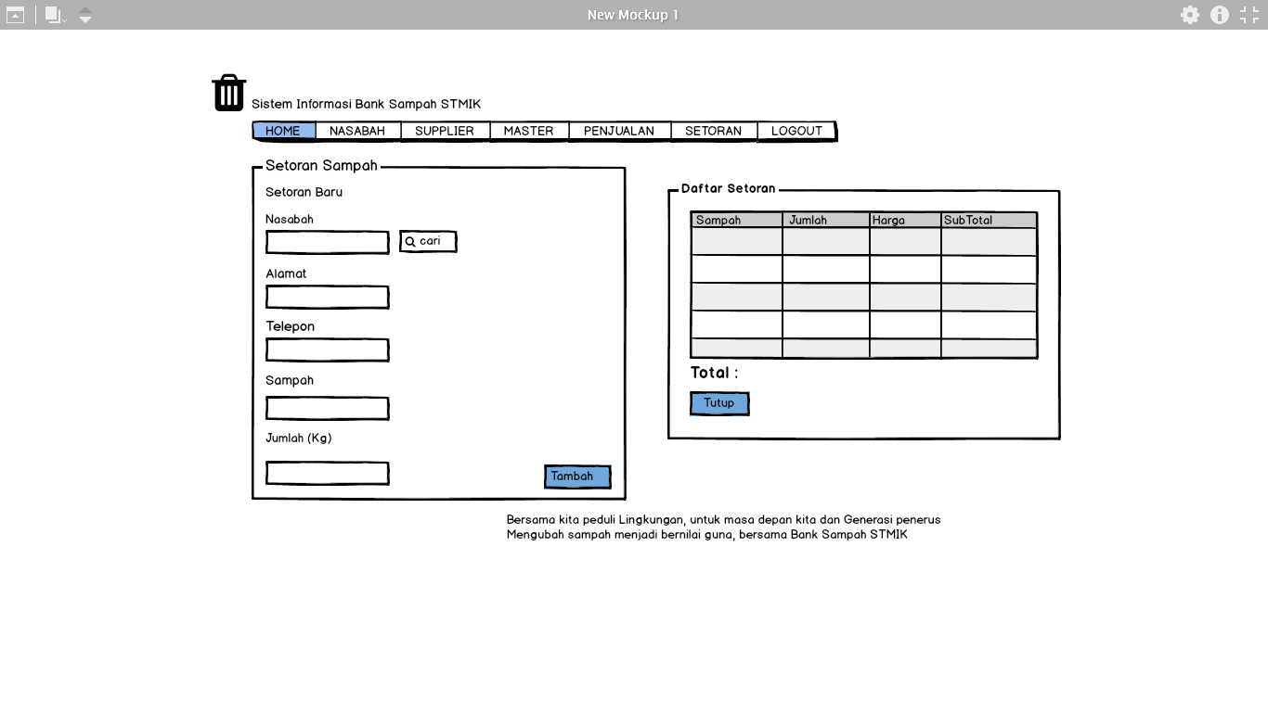**Mockup 1**
* 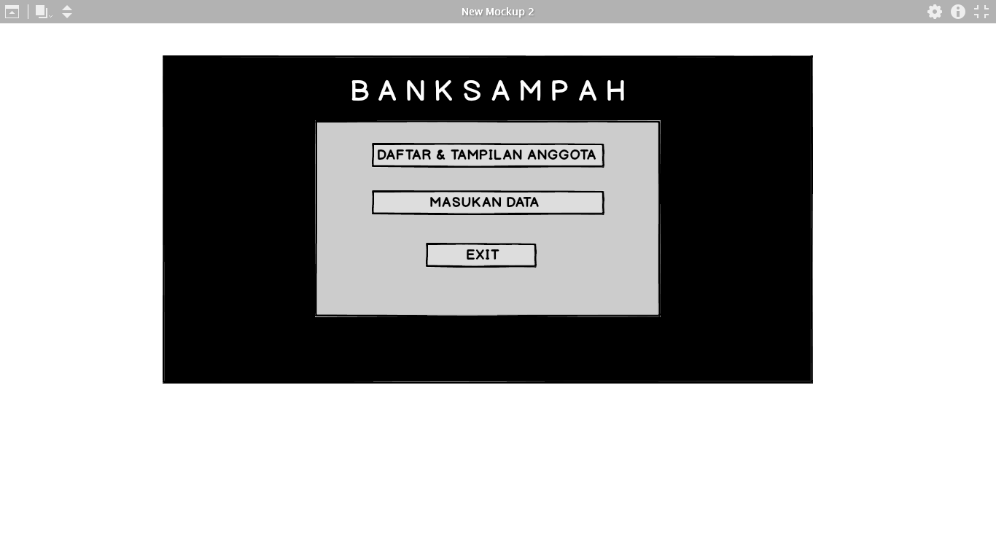**Mockup 2**
* 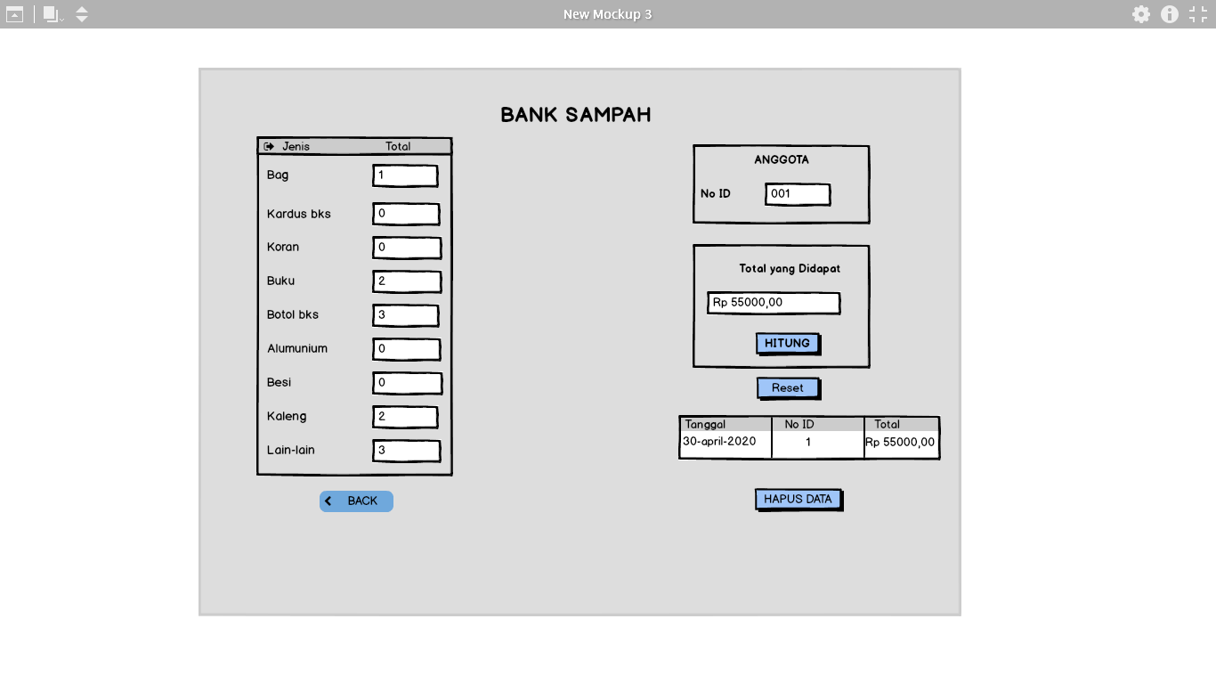**Mockup 3**
* 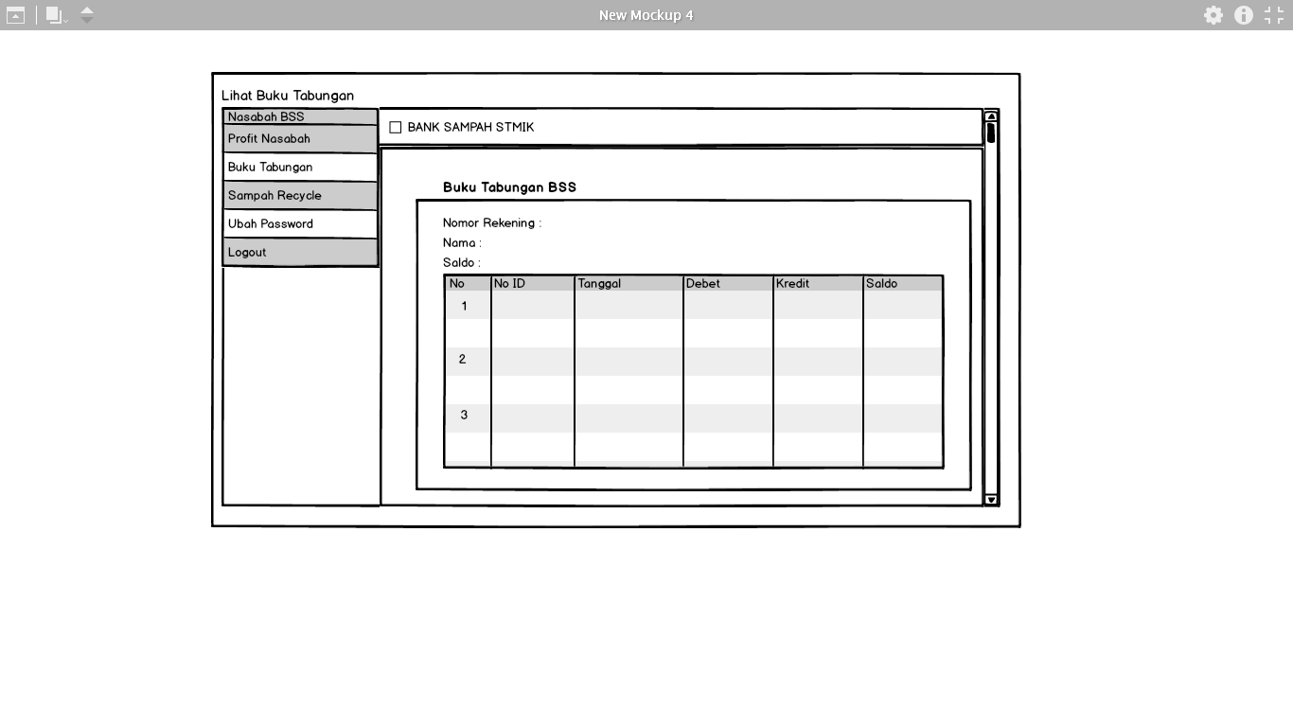**Mockup 4**